CHAFON Even Reader Software User Guide
目录
CHAFON Even Reader Software User Guide 1
1. Operating Environment 2
2. Open software 2
2.1 Connect to the software 2
3. ParameterSet 5
3.1 Read and Set parameters 5
3.2 Reader parameters 7
3.3 Reading settings 11
4. Answer mode 16
4.1 Query method 17
4.2 Query parameters 18
5. Active mode 20
6. Advanced settings 22
6.1 Reading permission 22
6.2 Output Control 23
7.Network settings 24
7.1 Network parameters 24
7.2 Remote parameters 25
7.3 WIFI Setting 26
8.Debug Assistant 27

1. Operating Environment
This software supports systems: Windows2000, Windows XP, Windows 7, Windows 8, Windows 10, Windows 2003 and higher systems.

Communication interface: support USB, RS232, RS485, WG26, RJ45, wifi, etc.

- Open software

2.1 Connect to the software

After selecting the appropriate interface and filling in the correct settings, if the device is connected normally and powered on, click the "Open" button. The software prompts "Open successfully", and it shows that the reading parameters are successful as follows:
Select the connected serial port number--the default baud rate is 115200--Open successfully--The page automatically displays that the read parameters are successful
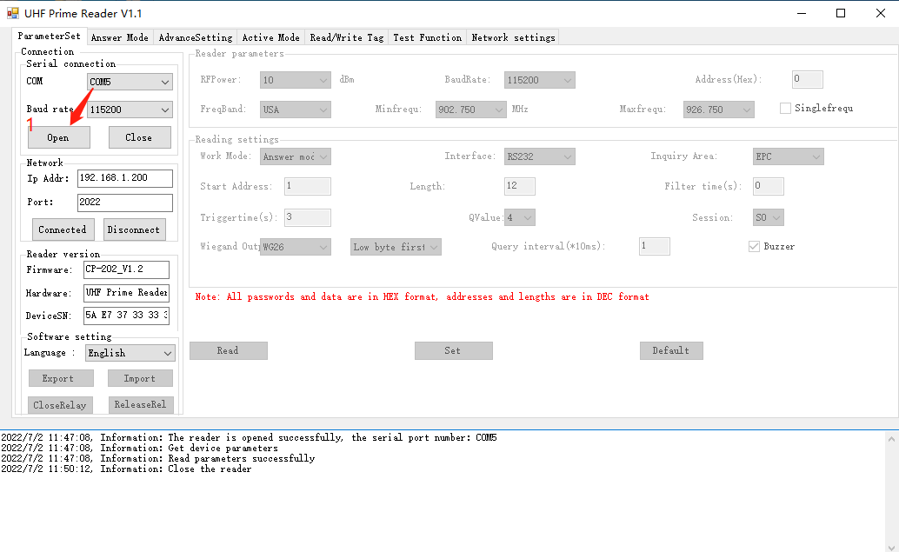

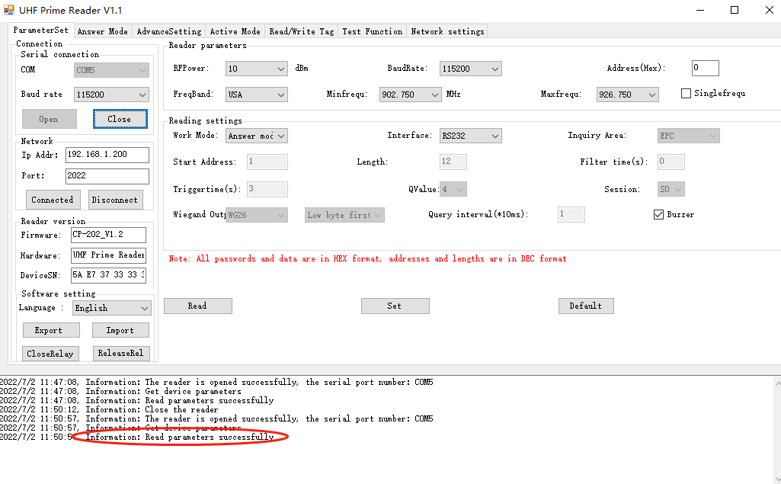
Note: If there is no corresponding device in the drop-down menu corresponding to the selected interface, please click the "Scan Port" button to scan the device.
Identifies whether the device connection is normal.

After the software is opened, the software can recognize the serial number and version of the device, and can choose different national languages. Export configuration, import configuration, relay closing and relay releasing are supported.
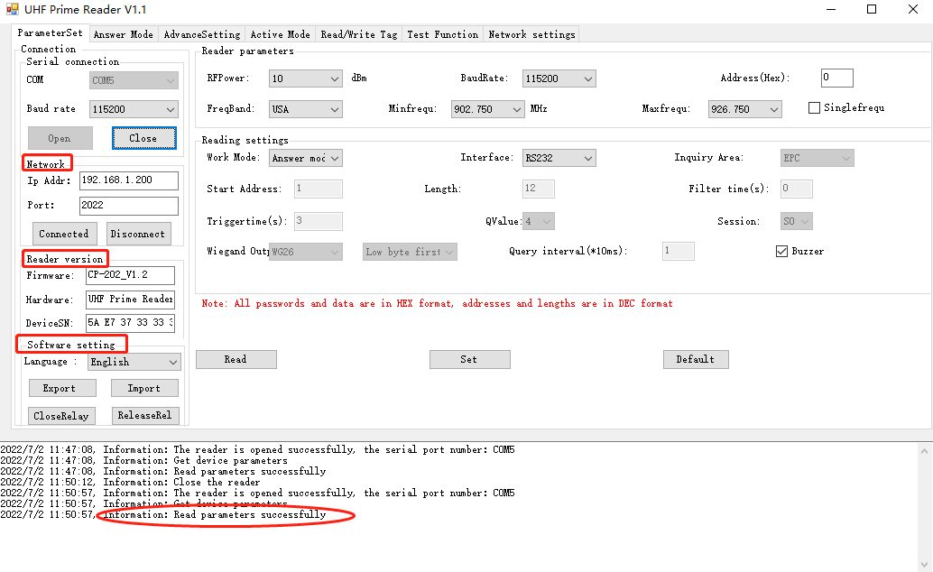
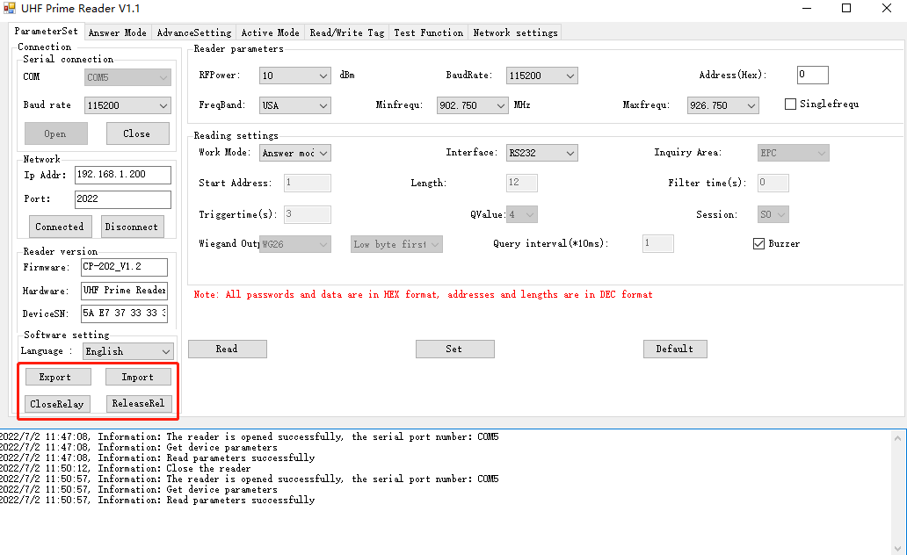

- ParameterSet

3.1 Read and Set parameters
3.1.1Get all parameters -- show the success of reading parameters
Click “Read” to get all parameters, including reader parameters and card reader setting parameters, check the following parameters and compare

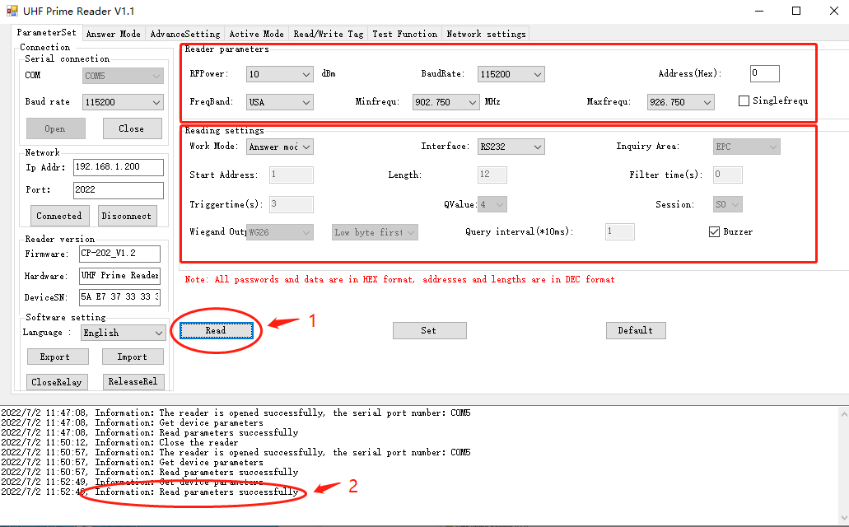

3.1.2 Set all parameters - set parameters successfully - can be set synchronously
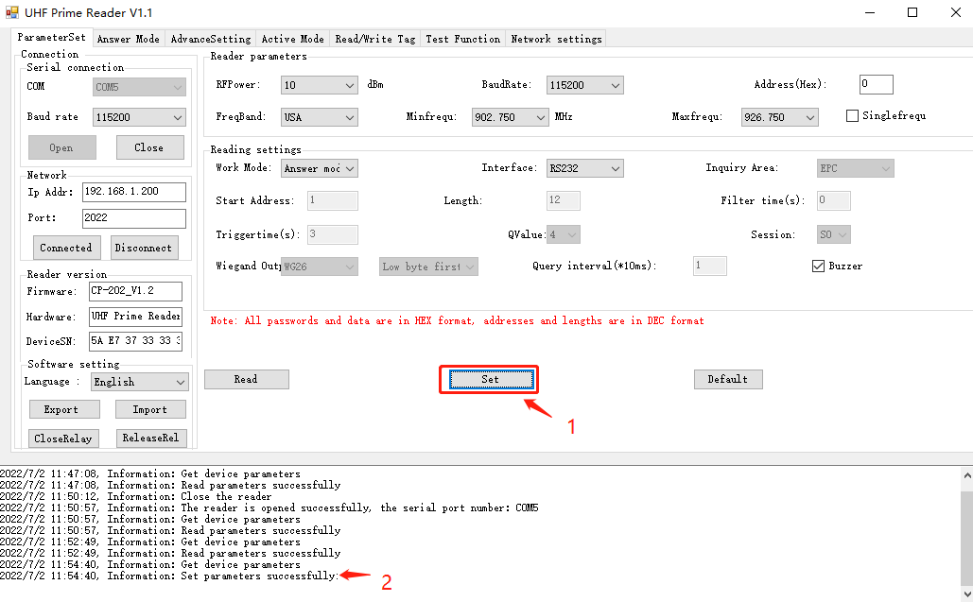

3.2 Reader parameters
(Reader parameter settings, including output power, baud rate, device address, working frequency band, start frequency and end frequency. Can be set individually or together)
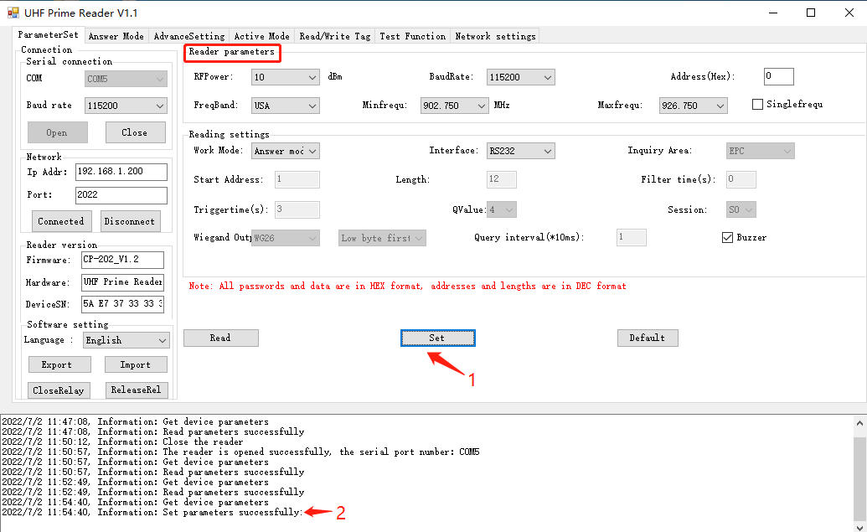

(1). Output power - set and save the power configuration
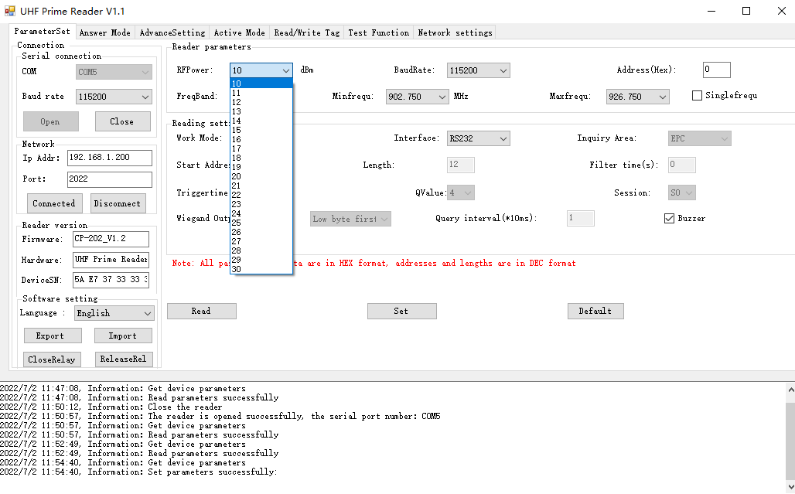

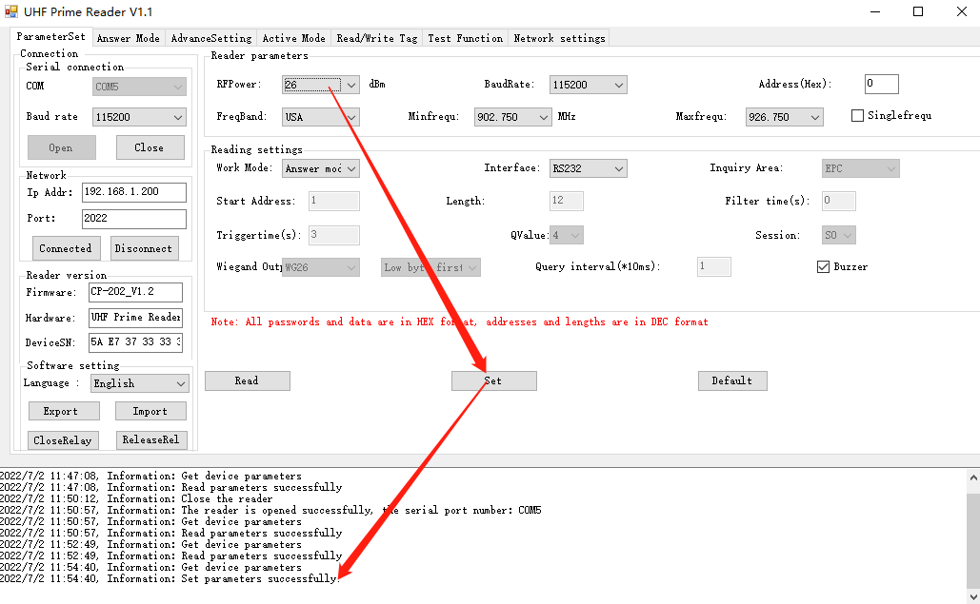

- .Baud rate--set all parameters successfully
Note: The software starts and runs, the default baud rate is 115200 to open the COM port, the reader is powered on, and the default baud rate of the reader is 115200. After modifying the baud rate, the reader will use the new baud rate until power off. Close the port and open the port, the baud rate does not change. The demo software will use the new baud rate until the demo software is closed
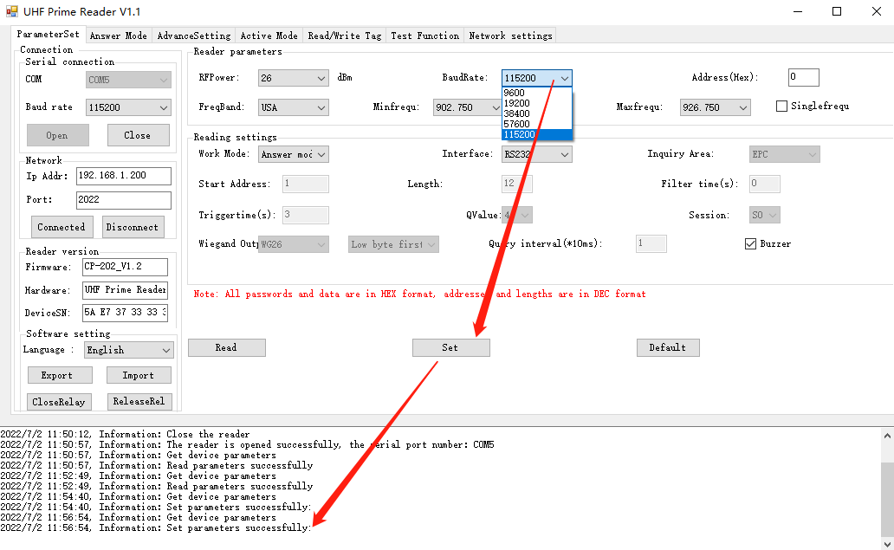
(3). Device address: (factory default is 0)
Note: New reader address settings. This address cannot be 0xFF. If set to 0xFF, the reader will return an error message
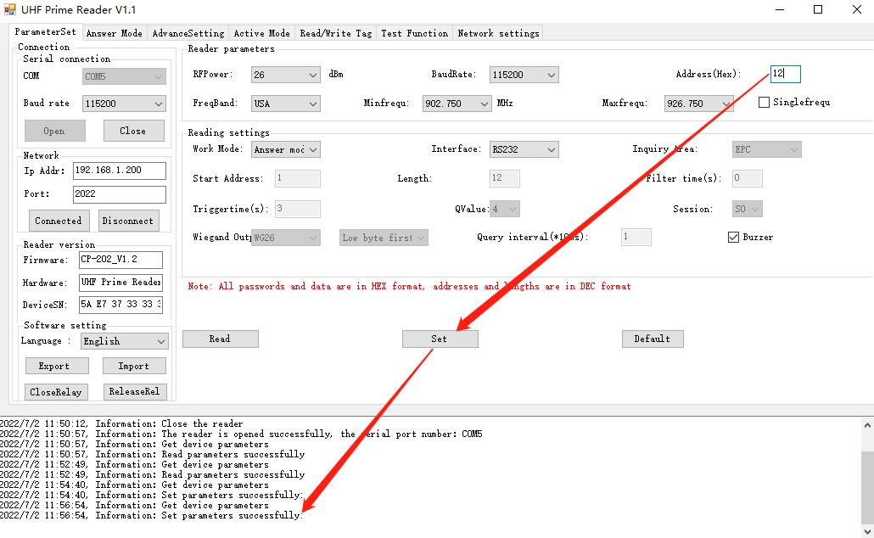

(4) Working frequency band
Choose different working frequency bands, different frequency bands have different frequencies
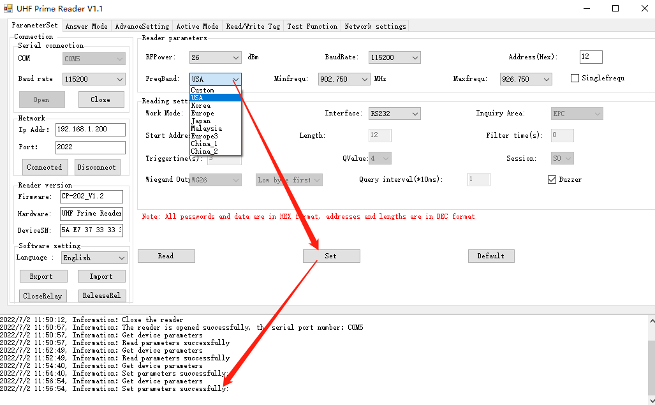
- Min frequency and Max frequency
Note: The setting Max frequency cannot be smaller than the min frequency, and the same frequency value is equivalent to a single frequency point
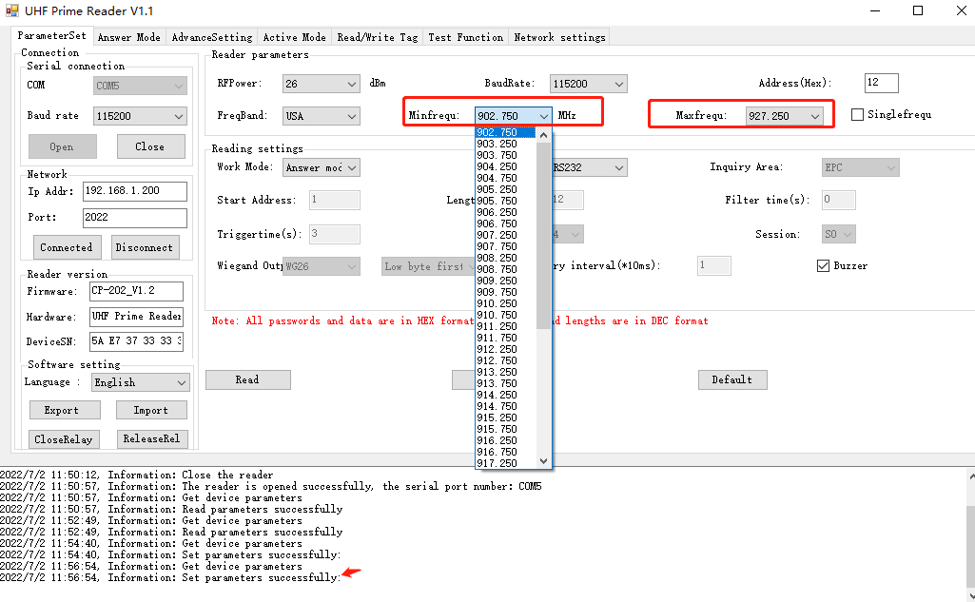

- Single frequency point - check the box - set all parameters
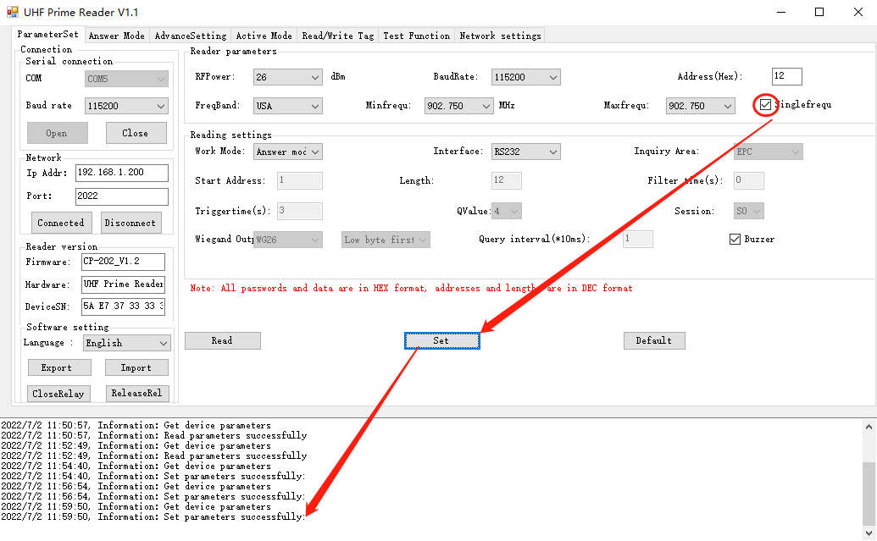

3.3 Reading settings
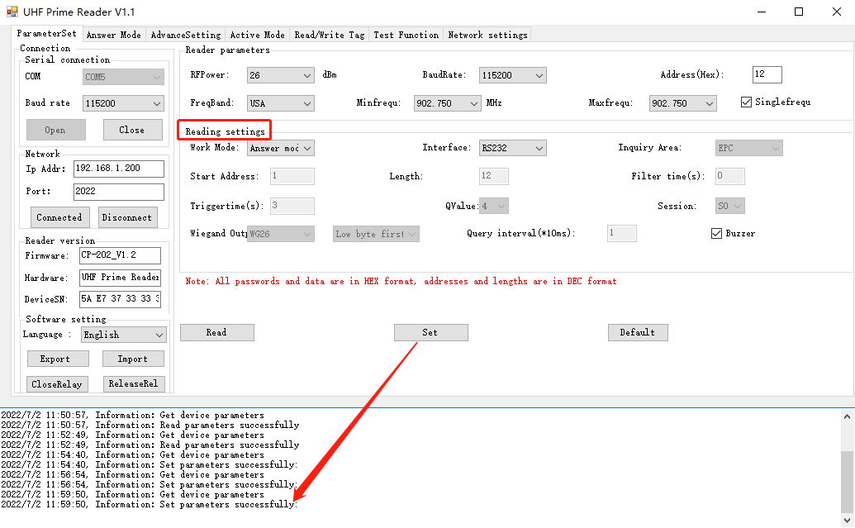

(1) Work mode
Working modes include: answer mode, active mode, trigger mode, the default is active mode before setting
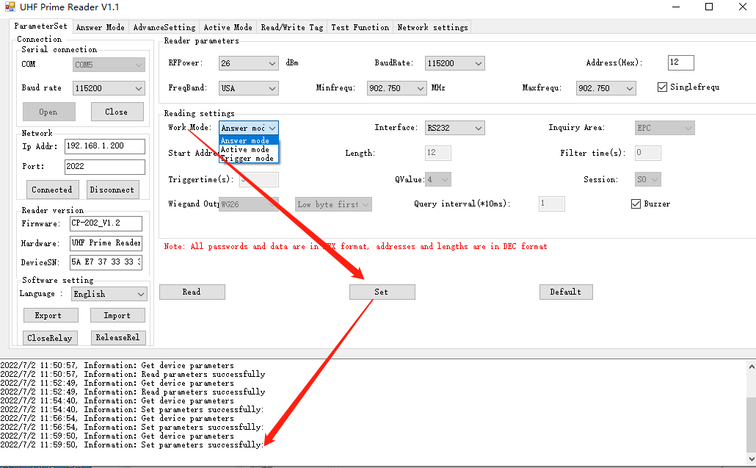

(2) Communication interface
The default communication interface is RS232, and it can also support Wiegand, RJ45 and other customized communication interfaces.
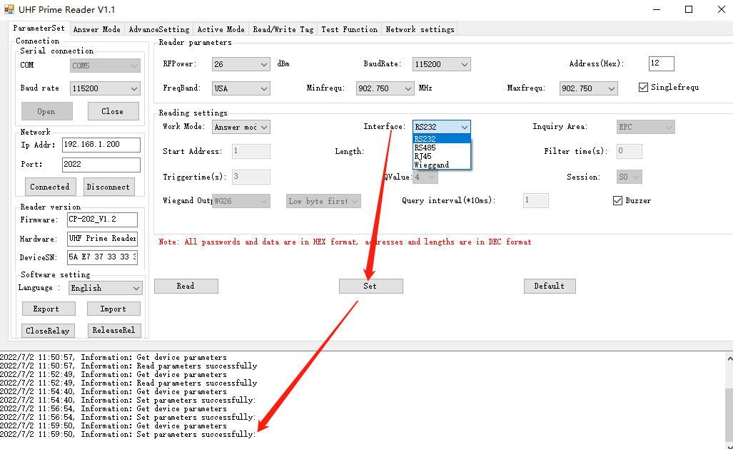

(3) Inquiry Area (ID)
Query area number according to different requirements of customers, choose different types of settings, (EPC default, RESERVE, TID, USER)
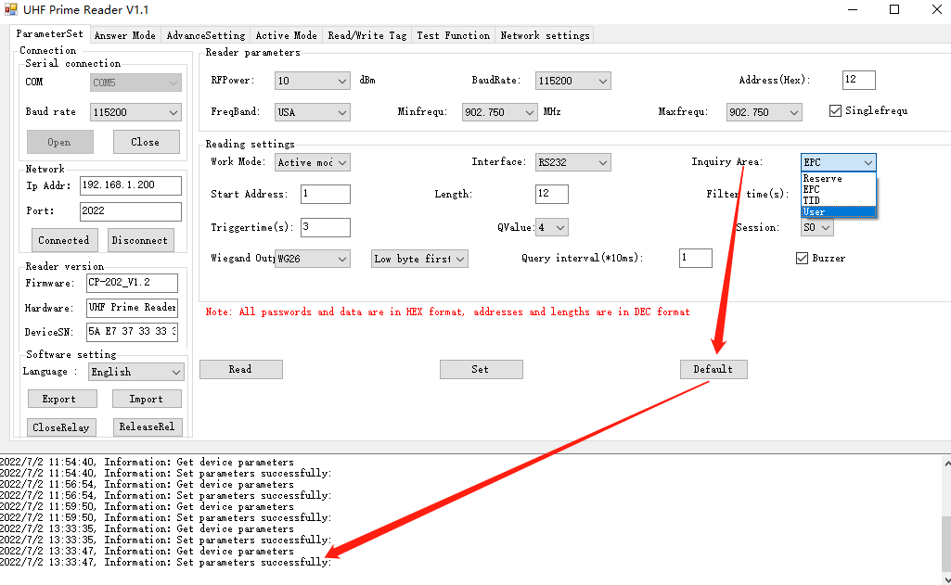

(4). The unit is byte, the default start address and length are 0, and all data are displayed; if the start address exceeds the data length, no data will be returned; if the byte length exceeds the data length, the maximum length will be displayed as much as possible .
(5). Filtering time: 0~255 seconds (interval time for each card reading)
(6). Trigger time: 0~255 (default is 0) when there is a label or card close to the card reader, the card reading is triggered, and the card is read for 3 seconds,Query time set after trigger mode

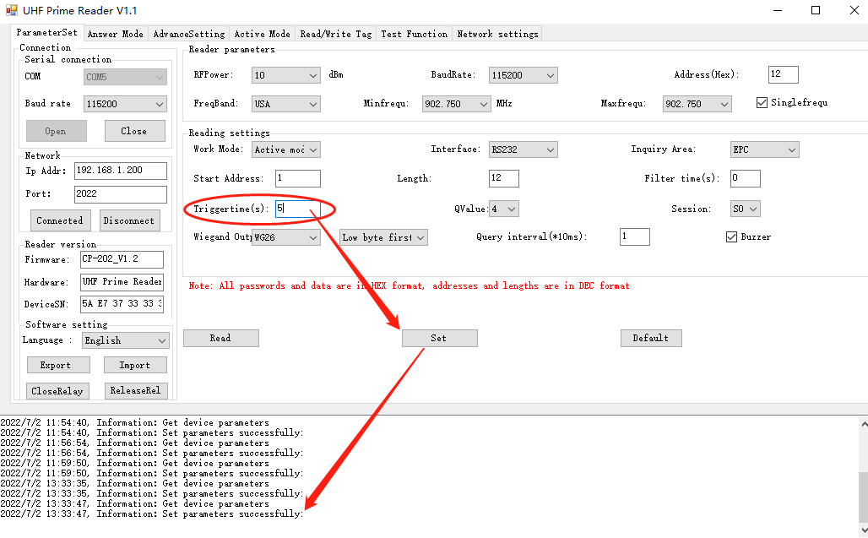
(7). Q value: 0~15 (default 4)
(8).Session: S0~S3 (default 0)
(9). Wiegand output: Wiegand 26, Wiegand 34 selection, Wiegand output format selection.
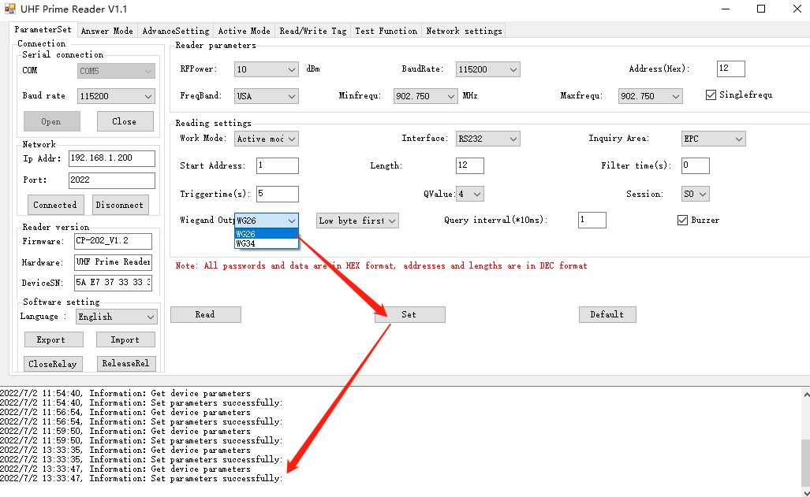

(10). Query interval time
(11) Buzzer: After clicking it, there will be a buzzer sound when the card or label is read. If not checked, there will be no sound when reading the card
.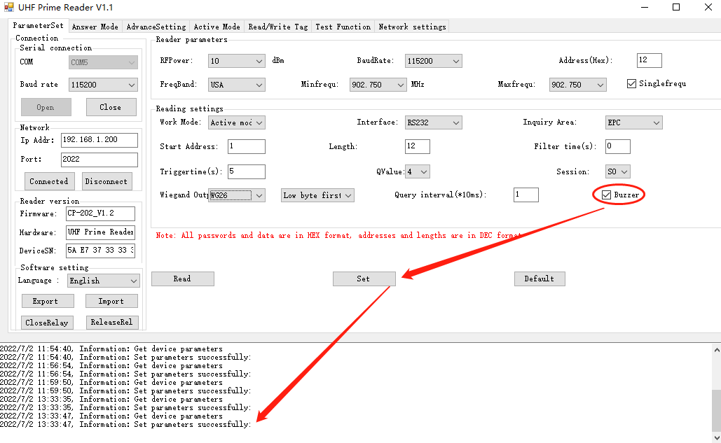

(12)Default parameters
Click the default parameter -- the page restores the default parameter value successfully
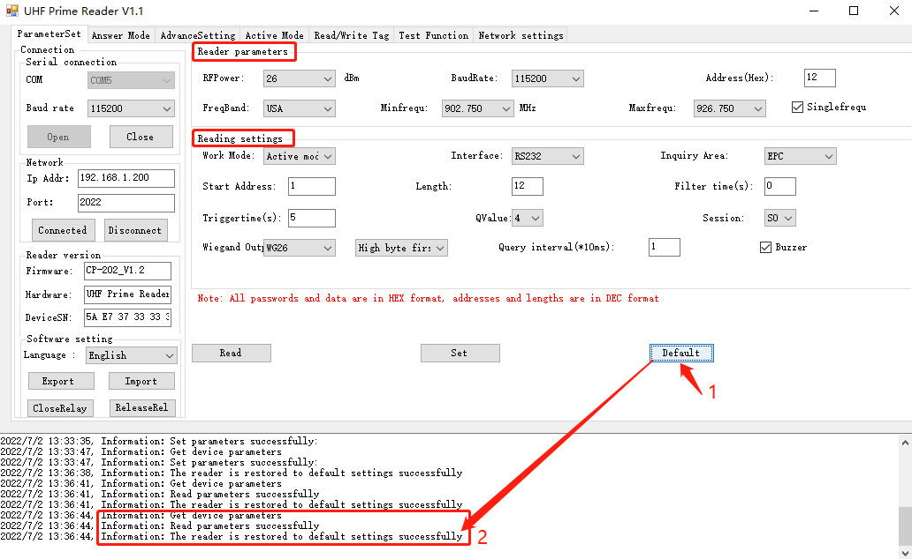

4. Answer mode
For answer mode, you need to select the working mode as answer mode in the card reader settings on the parameter setting page, then click to set all parameters, and then click answer mode interface 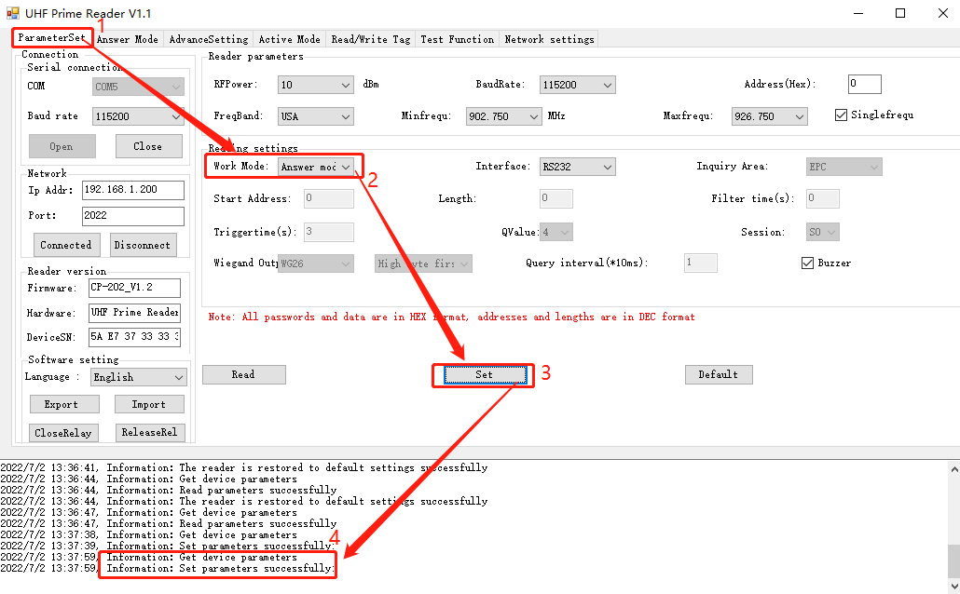
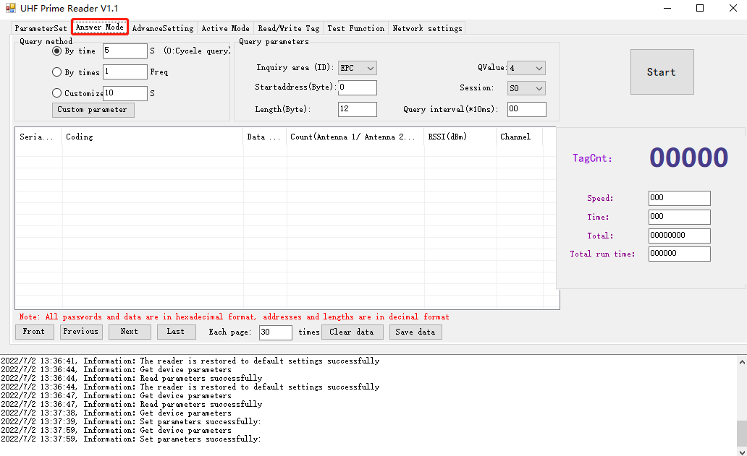

4.1 Query method
Query mode:
-Query by time: The default is 10 seconds (0 = continuous query) in seconds
-Query by number of times: the default is 1 time
-Customize: define the query time according to your needs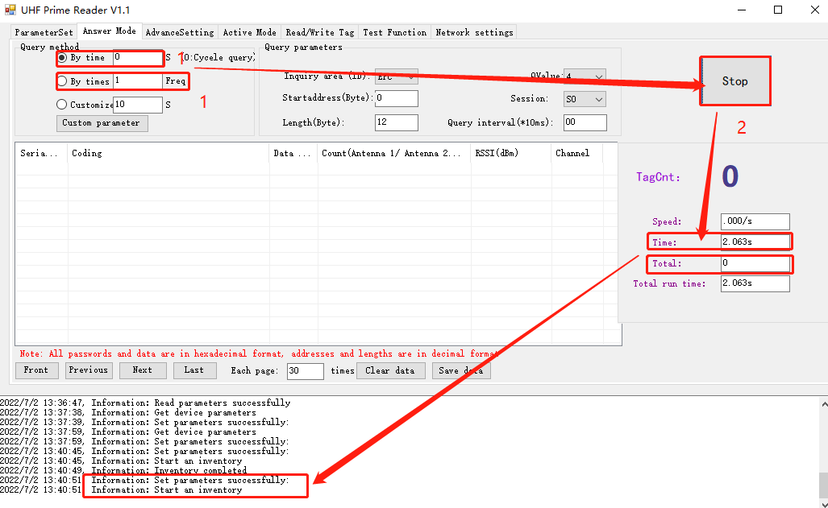

4.2 Query parameters
Query parameters:
(1)Query area (number): EPC, Reserve,TID, User
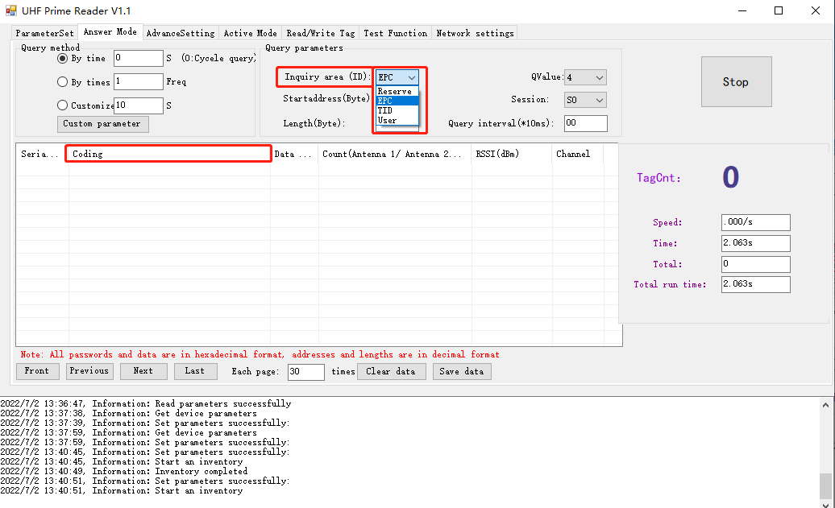
(2). Start address: query code display from 0 to 11 bytes (default is from 0 bytes)
(3). Byte length: The length of the encoded display after the query (default is 12 bytes)
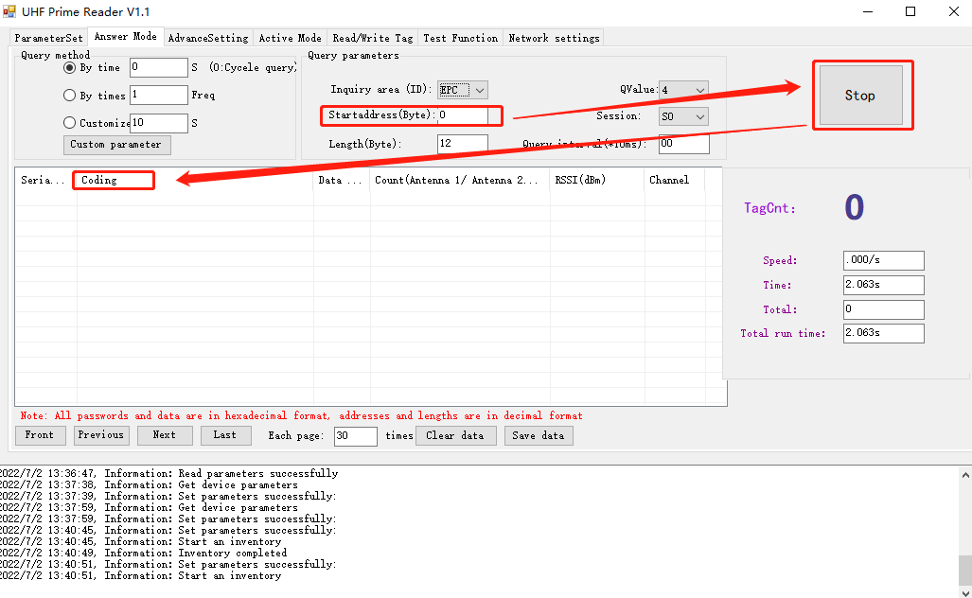

(4).Q value: 0~15 (default is 4)
(5).Session: S0~S3 (default is S0)
(6). Query interval time: (default is 00)
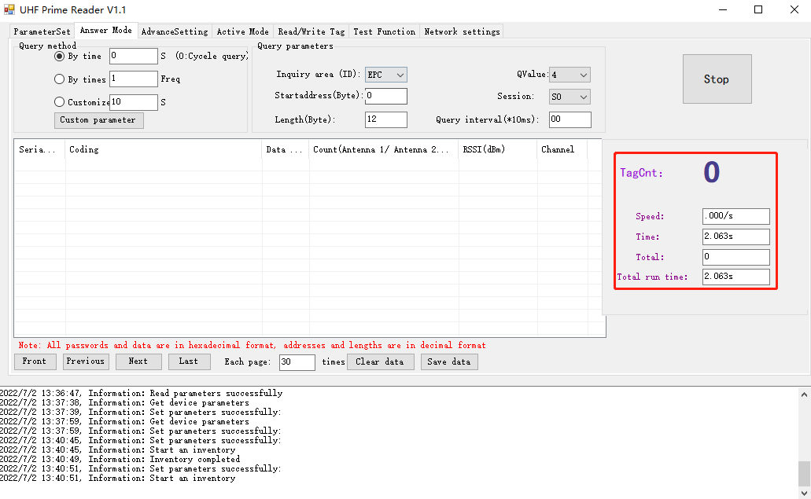
- TagCnt:The total number of tags per query
-Speed:Average speed of query tags
-Time:Total time per query
-Total:The total number of queries per query
-Total run time:Total time per tags reading

- Clear data:Clear the current query interface data
- Save data:Save the current query interface data in txt format
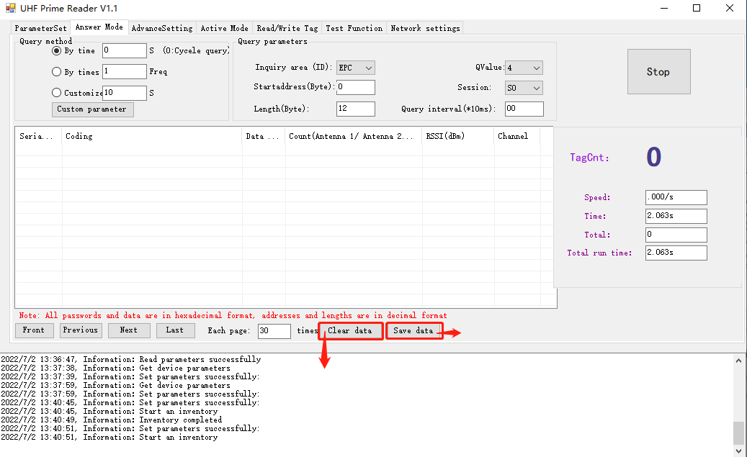

5. Active mode
To use the active mode, first select the working mode as the active mode in the parameter setting interface, then click to set all parameters, and click to return to the active mode
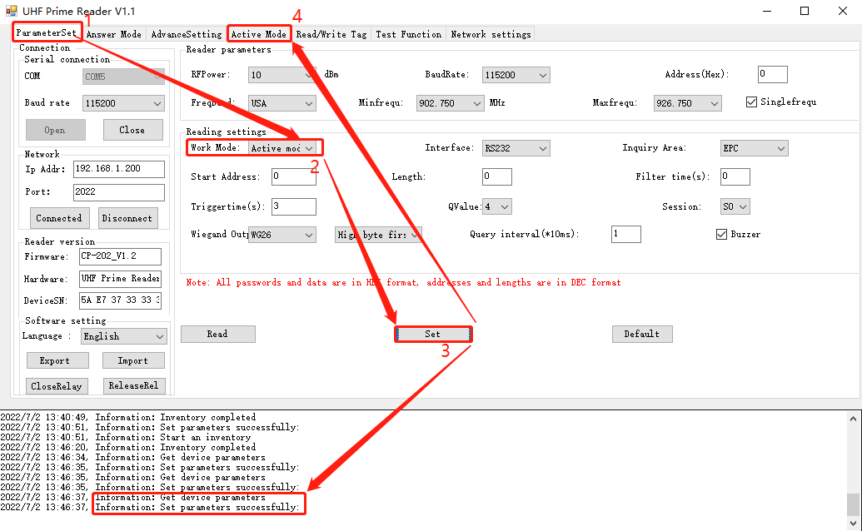

TagCnt:The total number of tags per query
-Speed:Average speed of query tags
-Time:Total time per query
-Total:The total number of queries per query
-Total run time:Total time per tags reading
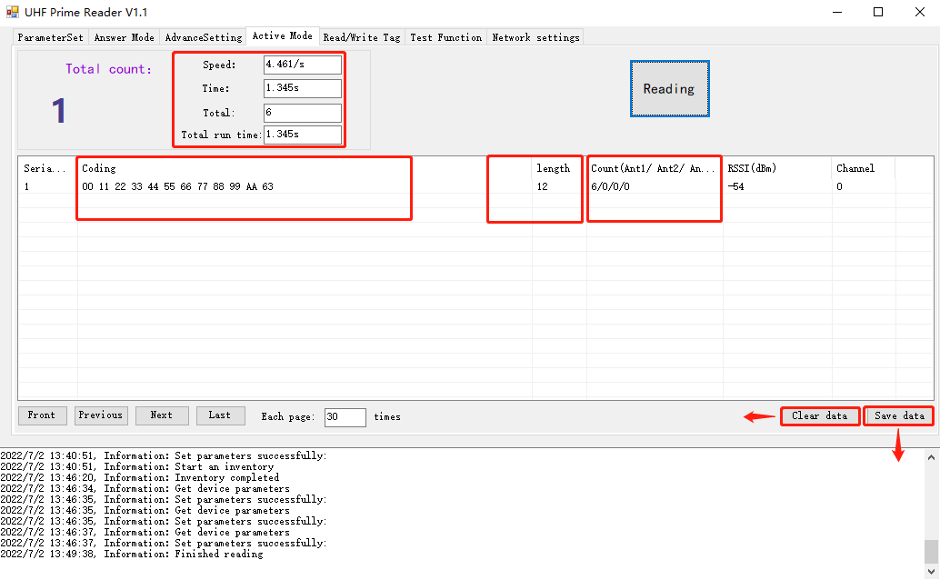

6. Advanced settings

6.1 Reading permission
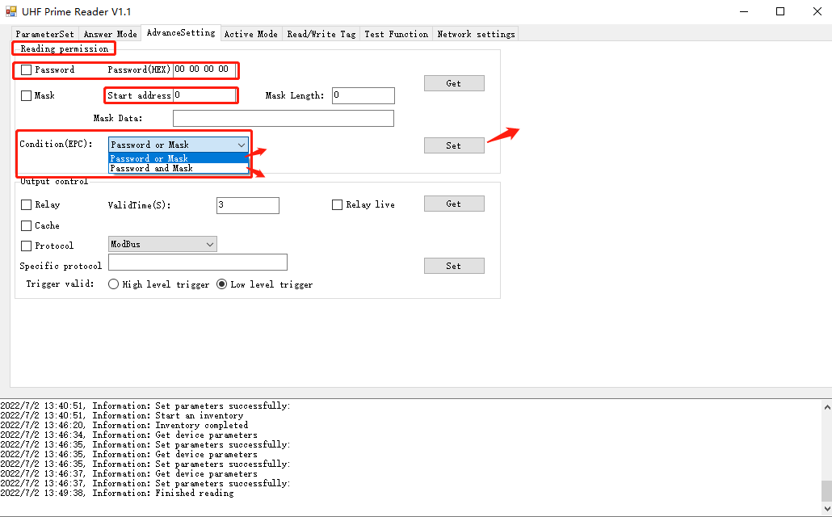
- Password:enter 8-digit hex password and click”Set”
- Mask:enter start address and mask length and click “Set”
Note: Prime reader supports the protection function, when you click "Get", the password and mask will be hidden to prevent the tag ID from being stolen by others
(3)User can choose different conditions to set the password mask to read the rfid tags.

6.2 Output Control
- Relay:Turn on the relay enable to set the valid time. For example: set 3 seconds, when the RFID tag was read by the reader, the relay will be triggered, the reading time is 3 seconds, and the relay will be closed after 3 seconds.
Relay can be powered.
- Cache:Data can be cached after network disconnection
- Protocol:Support custom communication protocol
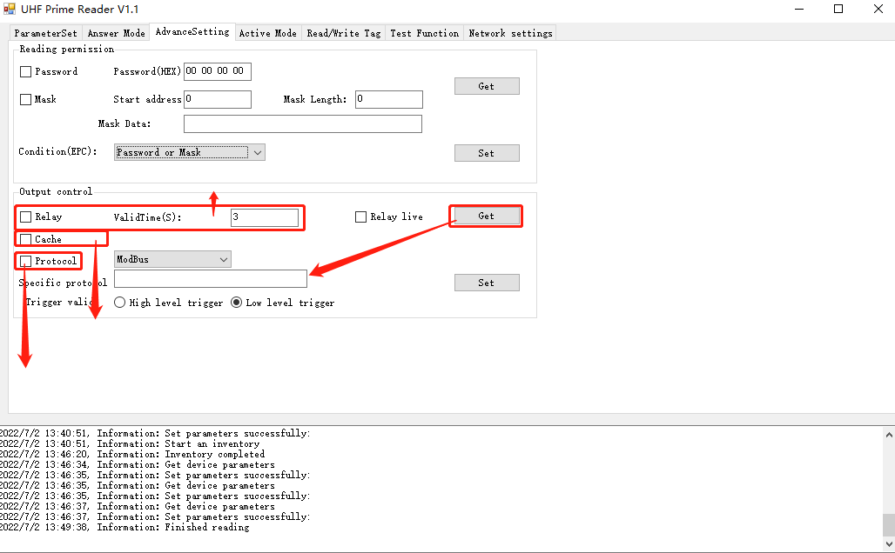
- High level trigger:Trigger card reading when high level
- Low leverl trigger::Trigger card reading when low level
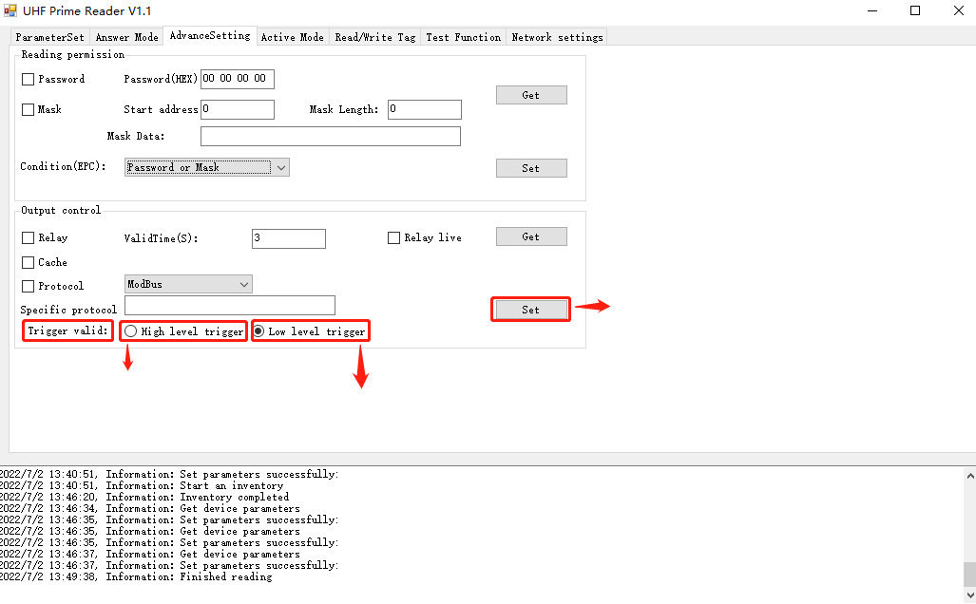

7.Network settings

7.1 Network parameters
IP:The IP address must be the same as the local IP address
Gateway:The default gateway must be in the same gateway as the IP address
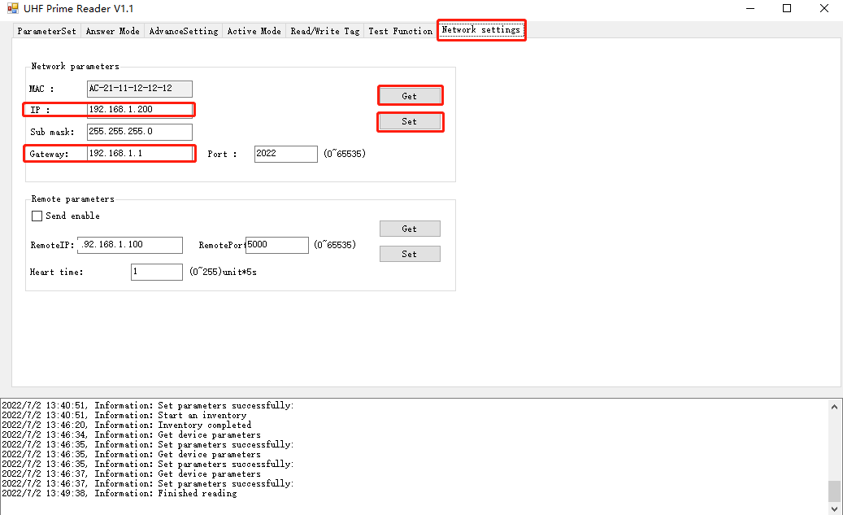

7.2 Remote parameters
Enter the remote IP address, send commands to the remote client, click Set after the input is complete
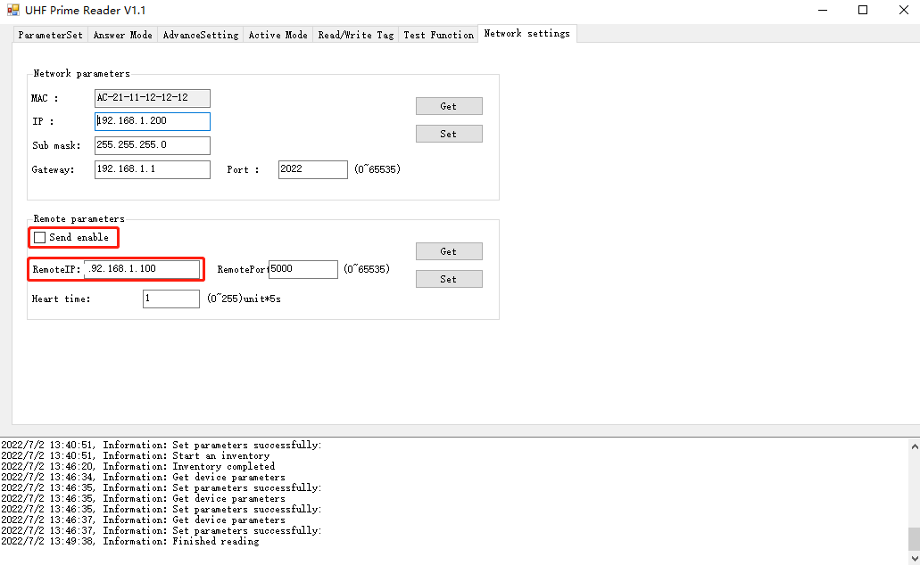

7.3 WIFI Setting
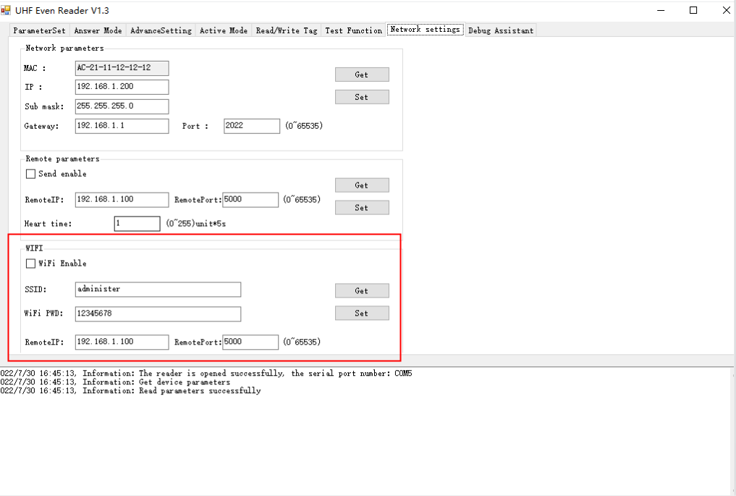

Turn on wifi enable, the wifi module can send data to TcpServer, the wifi connection has the following two processes
program:
1. Set the Wifi account password, the module will automatically connect to Wifi;
2. Set the remote server ip and port, the device will automatically connect to TcpServer;
After the configuration is successful, the device will automatically connect to Wifi and TcpServer.
How to judge whether Wifi and TcpServer are connected successfully:
After clicking the Wifi Settings button, the Wifi will be configured and connected to the TcpServer. At this time, TcpServer needs to be listening.
Status, the buzzer beeps long after connecting to Wifi, the buzzer beeps twice after connecting to TcpServer, or no
Connecting to the TcpServer will beep three times. The total setting process does not exceed 65S.

8.Debug Assistant
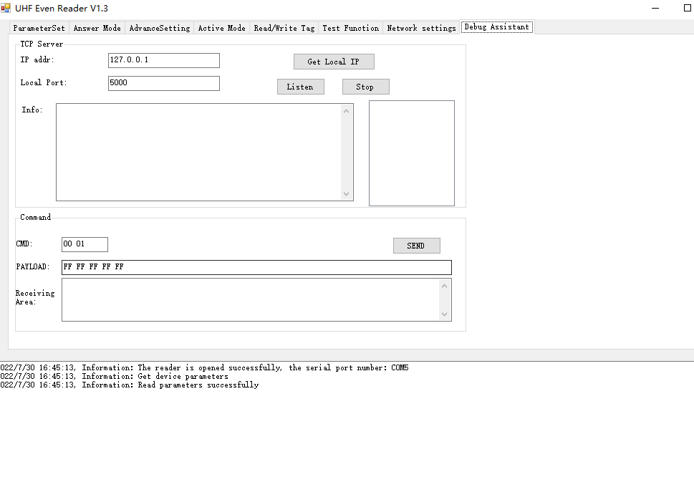
Click “Get Local IP” and “Listen”,Start listening and get data.

